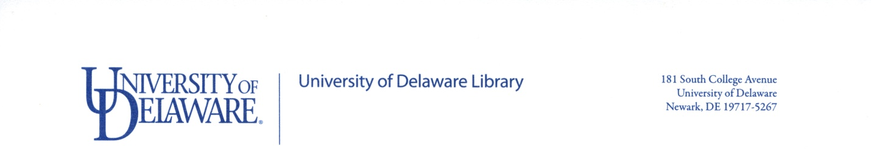

Multimedia Student Assistant (Part-time), Student Multimedia Design Center
DEADLINE: Open until filled
Description: Assist library users and provide troubleshooting support at the Student Multimedia Design Center service desk with computer hardware and software applications, most multimedia-related. Circulate and assist with equipment for loan, such as video cameras, microphones, and hard drives. Provide support for microform, CD-ROM, and map collections, and the equipment that services these collections, as well as self-service photocopiers and scanner/copiers. Create content related to the resources in the Student Multimedia Design Center to display in the site.
Qualifications: Working knowledge of one or more video editing applications, such as iMovie, Windows MovieMaker, Adobe Premiere and Final Cut, on MacOS or Windows. Preferred working knowledge of one or more of the following: Audacity, GarageBand, Publisher, Blender, Roxio Creator, Camtasia Studio and Adobe Creative Suite. Experience with general applications software; such as, Word, Access, Excel, and Power Point and general computer troubleshooting. Effective communication and interpersonal skills in individual and group settings. Experience in customer service with a commitment to providing high-quality service. (Please note specific multimedia experience on application form/ resume.)
Hours: Position scheduled to work approximately 10 hours per week, with a minimum of 6 hours. There will be training during and outside of scheduled work hours.
Student Multimedia Design Center hours of operation for Fall and Spring semesters: Sunday 11 a.m. to Midnight; Monday through Thursday 8 a.m. to Midnight; Friday 8 a.m. to 8 p.m.; and Saturday 9 a.m. to 8 p.m.
Pay Rate: $9.25 per hour.
To Apply: Complete University of Delaware Library Student Employment Application and send to Eve Ellis, Technology Support Specialist I, Student Multimedia Design Center, 055 Morris Library, 831-8832, eellis@udel.edu.
Learn more about the Student Multimedia Design Center at http://www.udel.edu/multimedia/.

Posted 11/2/16

